**FileStack Provider -** It Provides React SDK for integration. It also gives a picker where we can select different storage like google drive, dropbox, etc to upload our file. So file upload is not only limited to uploading the files from the Computer, we can upload from cloud to cloud. It has listed 20 sources from where we can upload the files. List of all sources can be found on this link <https://www.filestack.com/integrations/> .

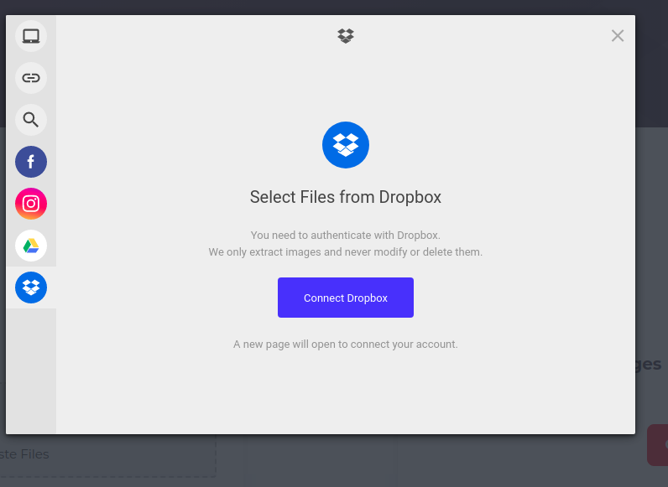

We can see the Fronted UI that file stack provides at this url - <https://www.filestack.com/sdks/react/>

**Storage in FileStack** - By default, Filestack stores uploaded files to an internally managed S3 bucket. If we already have a cloud storage solution in place and would like to integrate it with Filestack, filestack allow that as well. To do this, we have to log in to the Filestack Developer Portal and provide credentials of the service you’d like to use as your storage provider.

Currently, we supported cloud storage platforms:

* Amazon S3
* Rackspace
* Azure Blob Storage
* Dropbox
* Google Cloud Storage

**Virus Detection in FileStack** - File stack provides virus detection via the workflows . We can detect the virus asynchronously when file hits the storage. We can read more about workflows and there integration here <https://www.filestack.com/docs/workflows/overview/>.

**AI and Job Automation in FileStack -**  So basically we can create a webhook to send a mail or create a job which scans for malware and virus. Also we can perform some intelligence like image tagging, ocr etc.

**Security In FileStack -**  we can use IP white listing technique to secure uploads, so other sources cannot upload to our site.

**Pricing in FileStack -** So basically filestack provides different packages and we can create our own plan in the filestack. The plans provided is listed here: - <https://www.filestack.com/pricing/#/marketplace>  
Because we are not doing any audio, video or image transformation. It will be better that we create our own plan, which have virus scan, we can use our own AWS S3 bucket to upload, so wont required the filestack datasource. We can choose custom plan from this UI - <https://www.filestack.com/pricing/#/marketplace/plugins>. As per my calculations it will cost around 500$ Per month.

[Transloadit](https://transloadit.com/) - It provides its UI Component via an open source framework Uppy - <https://uppy.io/>, And Uppy integrates well with React. Uppy has a dashboard ui in which we can upload files via local computer, google drive, dropbox, we can check the UI from here <https://uppy.io/examples/dashboard/>.   
  
**Storage In Transloadit** - it internally uses its own storage, may be using s3 behind the scene but transloadit provide us the import/export functionality like we can import our data from amazon s3 to transloadit and export transloadit data to amazon s3. It do encryption on top of that. **Note - we can export files to our own ftp server, we just have to declare one json file in which we have to provide the ftp server configuration, all the transfer of the data will be encrypted, we can find more details on this link**

[**https://transloadit.com/demos/file-exporting/store-uploaded-files-over-ftp/**](https://transloadit.com/demos/file-exporting/store-uploaded-files-over-ftp/)

**Virus Detection In Transloadit -** It has the feature of virus scanning and detection which they call robots. **The /file/virusscan** Robot rejects millions of trojans, viruses, malware & other malicious threats before they reach your platform**.  
  
Other Features - The list of all features can be found over this link**

[**https://transloadit.com/demos/**](https://transloadit.com/demos/)

**Pricing - Pricing of transloadith can be found here -**

[**https://transloadit.com/pricing/**](https://transloadit.com/pricing/)

**They do offer custom plans but they are not explicit as filestack website.**

**Cloudinary - They have the same widget like filestack and transloadith. Similarly they provide integration with google drive, dropbox etc.**

**We can see there UI at this url**

[**https://cloudinary.com/documentation/upload_widget**](https://cloudinary.com/documentation/upload_widget)

**Storage in cloudinary - I couldn’t find any storage other there cloud. This is biggest lacking in there solution**

**Virus detection in cloudinary - This feature is provided as add on. They have two workflow for scanning viruses. First is automatic- means file uploaded to cloudinary, status remain pending, scanner scan the files, if passed then it appears in media library, if rejected then it do not appear in media library, second is through api - we can request file scanning in api moderation.  
Full detail can be foud on this link -**[**https://cloudinary.com/documentation/metadefender_anti_malware_protection_addon#:~:text=Cloudinary%20provides%20an%20add%2Don,your%20website%20or%20mobile%20application.**](https://cloudinary.com/documentation/metadefender_anti_malware_protection_addon#:~:text=Cloudinary%20provides%20an%20add%2Don,your%20website%20or%20mobile%20application.)

**Pricing in cloudinary - pricing details can be found here. It is basically categorized in three parts like Programmable media, Media optimizer, Digital Assest management. Full details can be found here**

[**https://cloudinary.com/pricing**](https://cloudinary.com/pricing) **Upload Care - This provide the same widget as others, which includes from local storage to clouds like google drive, dropbox etc**[**https://uploadcare.com/docs/uploads/file-uploader/**](https://uploadcare.com/docs/uploads/file-uploader/)

Storage in upload care - Basically provides two storage, its own and amazon s3, but s3 storage is limiting, in terms of functionality.

We can find more details on this link

<https://uploadcare.com/docs/uploads/storage/>

Virus Detection in Upload care - Currently they dont have any process which support virus scanning. This is biggest lack in there service. A open source chat can be found for this feature can be found here

<https://uploadcare.com/community/t/virus-check-process/128>